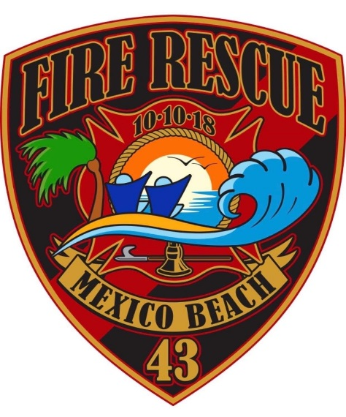
Mexico Beach Fire Rescue
201 Paradise Path, Mexico Beach, Florida 32456
PHONE: 850-704-9190. CELL: 850-339-4514

11/15/2022

To Whom it May Concern.

As of November 1, 2022 the ISO rating for the Mexico Beach Fire Rescue has been lowered from a 6/6X to a 4/4X. If you require any further information on the closest hydrant or flow rates for the closest hydrant, please contact Chief Walker at s.walker@mexicobeachgov.com

Sincerely,

Donald “Sandy” Walker
Fire Chief

